# **13.2 Guided Exercise: Passive Information Gathering**

|  |  |
| --- | --- |
| **Resources** | |
| Files | None |
| Machines | None |

In this exercise you are required  to search and find  publicly available information for the domain hackthissite.com. You will need to use a web browser for this exercise not in the lab environment.

Go to the link <https://www.netcraft.com/> and in the text box under What’s that site running enter https://www.hackthissite.org and press Enter.

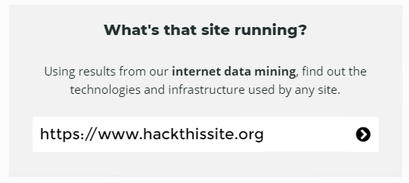

1. Once the results are revealed identify the IP address.
2. Which is the Nameserver of the domain?
3. Which is the Nameserver organisation?
4. Which is the Hosting country?
5. What is the Reverse DNS?